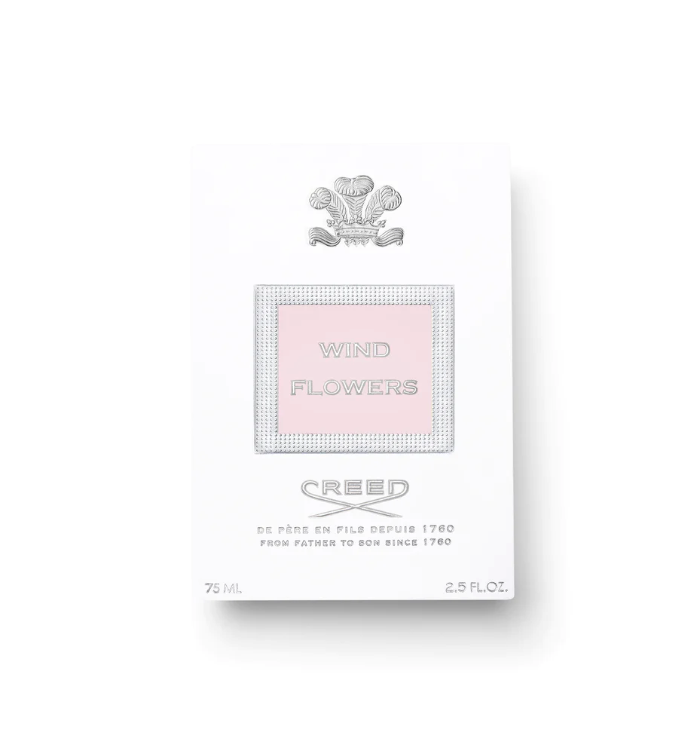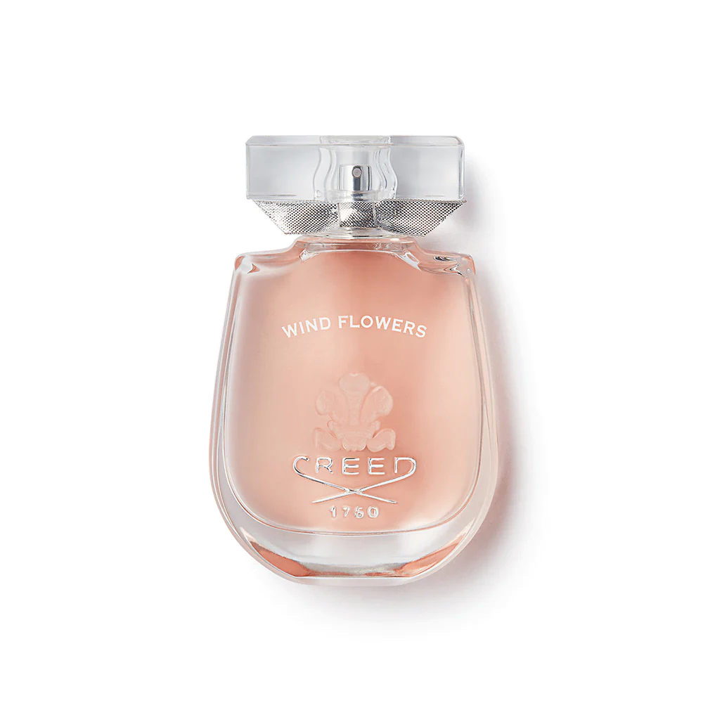

CREED WIND FLOWERS

$445.00

Tax Included.

Spray 100 mL

IN STOCK

### Product Details

A vibrant note of orange blossom and creamy praline offsets this dusky floral scent; bringing to life this luminous fragrance for her.

Floral and fresh, this fragrance opens with sweet jasmine, wrapped around the zesty scent of Tunisian orange blossom and softened by a fresh and a fruity peach note, a powerful heart of delicate jasmine flower, tuberose petals and a soft rose extract add depth and texture to this fragrance while a warm flurry of sandalwood is twisted around a haze of iris and musk.